Green Synthesis of Cellulose Nanocrystal/ZnO Bio-nanocomposites Exerting Antibacterial Activity and Downregulating Virulence Toxigenic Genes of Food-Poisoning Bacteria
Ghada E. Dawwam¹, Mona T. Al-Shemy^{2*}, Azza S. El-Demerdash³
¹ Botany and Microbiology Department, Faculty of Science, Benha University, Benha, Egypt
² National Research Center, Cellulose and Paper Department, 33 El-Bohouth St. (Former El-Tahrir St.), Dokki, Giza, Egypt. P.O. 12622
³ Agriculture Research Center (ARC), Animal Health Research Institute (AHRI), Zagazig, Egypt
*Corresponding author: Mona T. Al-Shemy. E-mail: mt.el-shemy@nrc.sci.eg. Orcid ID: 0000-0001-9290-5955. Tel: +2-01154456633. El Buhouth St., Dokki, Cairo, Egypt Postal Code 12622

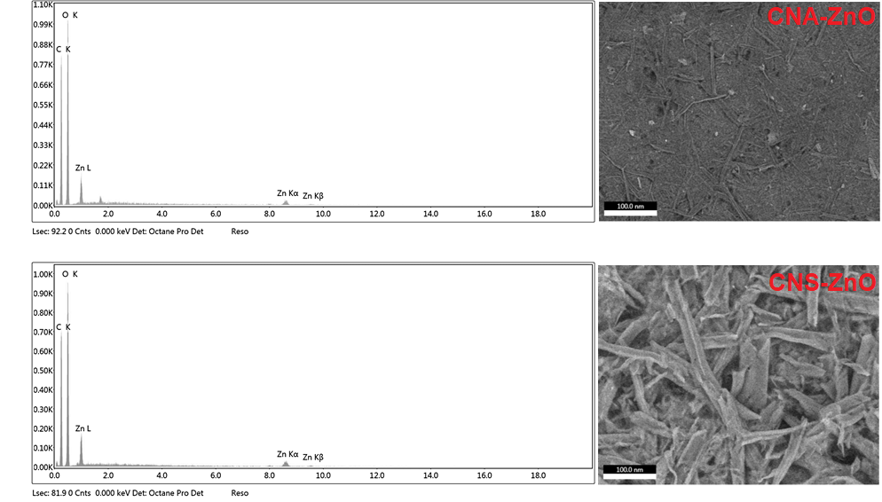
EDX and SEM analysis of fabricated materials

